|  |  |
| --- | --- |
|  | 15th October 2024 |

|  |  |
| --- | --- |
| **Application number:** | 24/01469/LBC |
|  |  |
| **Decision due by** | 2nd September 2024 |
|  |  |
| **Extension of time** | 25th October 2024 |
|  |  |
| **Proposal** | Reconfiguration of internal areas to include the reduction in size of the ground floor entrance lobby, relocation of a door opening into the TV room and refurbishment of the kitchen including floor finishes. Floor to be part excavated for floor build-up. New internal door openings. Insertion of a structural steel beam. |
|  |  |
| **Site address** | 8 Dunstan Road, Oxford, Oxfordshire, OX3 9BY – see **Appendix 1** for site plan |
|  |  |
| **Ward** | Headington Ward |
|  |  |
| **Case officer** | Bruce Edgar |

|  |  |  |  |
| --- | --- | --- | --- |
| **Agent:** | Ms Dominique Andrews | **Applicant:** | Ms Mary Clarkson and Mr Michael Tappin |

|  |  |
| --- | --- |
| **Reason at Committee** | The application has been submitted on behalf of a councillor. |

1. RECOMMENDATION
   1. Oxford City Planning Committee is recommended to:
      1. **approve the application** for the reasons given in the report and subject to the required planning conditions set out in section 13 of this report and grant planning permission; and
      2. **agree to delegate authority** to the Head of Planning Services to:

* finalise the recommended conditions as set out in this report including such refinements, amendments, additions and/or deletions as the Head of Planning Services considers reasonably necessary.

1. EXECUTIVE SUMMARY
   1. This report considers the Listed Building Consent for works relating to the erection of a single storey extension to the rear of the existing building and the associated fenestration alterations. The specific works that require listed building consent are the reconfiguration of internal areas to include the reduction in size of the ground floor entrance lobby, relocation of a door opening into the TV room and refurbishment of the kitchen including floor finishes. In addition, it is proposed to part excavate the kitchen floor to allow for a floor build-up, new internal door openings and the insertion of a structural steel beam within the kitchen.
   2. Officers conclude that the proposed development is acceptable with regards to its design, its impact on the significance of designated heritage assets, subject to the recommended conditions. Overall, the proposal is considered to be in accordance with policies DH1 and DH3 of the Oxford Local Plan 2036 policies.
2. LEGAL AGREEMENT
   1. This application is not subject to a legal agreement.
3. COMMUNITY INFRASTRUCTURE LEVY (CIL)
   1. The proposal is not liable for CIL
4. SITE AND SURROUNDINGS
   1. 8 Dunstan Road, originally known as Lower Farm, is a detached property located on the northern side of Dunstan Road with the front (southwest) stone elevation immediately abutting the pavement. There is a walled garden to the rear and a large field beyond the garden which is within the ownership of the applicants.
   2. The property is in the northwestern corner of Old Headington Conservation Area and the building is of significance being Grade II Listed. As a Grade II Listed building, the property possesses historic and architectural special interest which is largely derived from its historic character and appearance as a vernacular farmhouse which is a reminder of the rural character of Old Headington.
   3. Lower Farmhouse was fully refurbished in 2002-2003, under applications 01/00766/NFH and 01/00765/L, creating the layout as shown on the existing plans. This refurbishment included the outbuildings which have been sympathetically extended, converted, and incorporated into the footprint of the main house. The historic stone boundary wall to the street has been retained. A conservatory has also been constructed to the rear.
   4. The two-storey outbuilding immediately to the east of the main house was extensively modified to allow full use of the ground and first floor spaces. The rear wall of the outbuilding was rebuilt in brick and stone and it was re-roofed resulting in the creation of an overhanging roof canopy which created a covered porch entrance to the rear of the property.
   5. See block plan below:

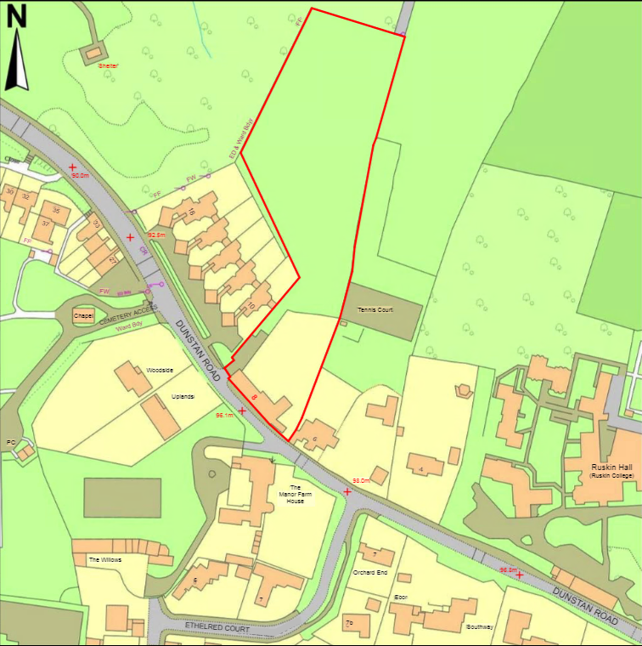

1. PROPOSAL
   1. The application seeks listed building consent to reconfigure the internal areas of the building to include the reduction in size of the ground floor entrance lobby, relocation of a door opening into the TV room and refurbishment of the kitchen including floor finishes, with the floor to part excavated to allow a new floor build-up. Also proposed are new internal door openings and the insertion of a structural steel beam within the kitchen.
   2. The extension would infill the covered porch area created under applications 01/00766/NFH and 01/00765/L. The area infilled would measure approximately 3.7m wide by 1.7m deep and would result in an enlarged kitchen/dining area. The rear entrance door would be retained and the run of casement timber windows would be continued along the length of the newly aligned rear wall. The extension would be constructed in brick to match the brick found within the existing rear elevation of the outbuilding and timber casement windows would be installed to match those as existing.
   3. Separate planning permission for the scheme has already been approved by committee on 17th September 2024 under application 24/01468/FUL.
2. RELEVANT PLANNING HISTORY
   1. The table below sets out the relevant planning history for the application site:

|  |
| --- |
| 01/00765/L - Listed building consent for external alterations and additions including new dormers and roof lights on rear roof slopes; insertion of rooflights on front roof slopes; new roof on outbuilding; bay window, conservatory and loggia on rear elevation; replacement of existing windows and relocation of front door. Internal alterations including removal of existing staircase and internal partitions and wall and installation of new stair case. Approved 12th December 2001.  01/00766/NFH - Alterations and additions including the insertion of new dormers on rear roof slopes, new roof on outbuildings and bay window, conservatory and loggia on rear elevation.. Approved 12th December 2001.  02/01597/LBC - Listed Building consent for formation of opening in rear garden wall and installation of new steel gates and stone steps. Setting back of vehicular entrance gates.. Approved 1st November 2002.  02/01598/FUL - Planning permission for formation of opening in rear garden wall and installation of new steel gates and stone steps. Setting back of vehicular entrance gates.. Approved 1st November 2002.  06/00596/FUL - Erection of two outbuildings. Approved 2nd June 2006.  24/01468/FUL - Erection of a single storey rear infill extension. Removal of 1no. window and 1no. door. Insertion of 4no. windows and formation of stone thresholds to the rear elevation. |

1. RELEVANT PLANNING POLICY
   1. The following policies are relevant to the application:

|  |  |  |
| --- | --- | --- |
| **Topic** | **National Planning Policy Framework** | **Local Plan** |
| **Design** | 131 – 141 | DH1 - High quality design and placemaking |
| **Conservation/ Heritage** | 195 – 214 | DH3 - Designated heritage assets |

1. CONSULTATION RESPONSES
   1. Site notices were displayed around the application site on 23rd July 2024 and the three-week consultation period expired on 13th August 2024.
   2. The application was also advertised in the Oxford Times on 18th July 2024.

**Statutory and non-statutory consultees**

* 1. Friends of Old Headington – letter of support.

**Public Representations**

* 1. No representations were received.

1. PLANNING MATERIAL CONSIDERATIONS
   1. Officers consider the determining issues to be:
2. Significance of the heritage assets
3. Harm that would be caused to significance of heritage assets by the proposed alterations.
4. Justification for the proposed alterations to the heritage assets.
5. Mitigation of any resultant harm to the significance of heritage assets through design.
6. Balance of harm against any public benefits that would arise directly as a result of the proposed alterations.
   1. **Significance of the Heritage Assets**
   2. The property is a grade II listed building and located within the Old Headington Conservation Area, both of which are designated heritage assets.
   3. Lower Farm originally consisted of the main farmhouse with outbuildings to its east. The main farmhouse was originally a two-storey stone building built under a slate roof. The front elevation contains 5no. 12-paned timber sash windows and a 6-panel timber front door, all of which are still present. Constructed from local limestone, it is a two and a half storey building which probably dates from the second half of the 19th century but likely incorporating the remains of an earlier building with 18th century fabric. It is a good example of local vernacular architecture for which it derives it’s significance.
   4. Old Headington Conservation Area retains the character of a quiet rural village largely built between the 17th and 19th centuries within an attractive green setting despite encroachment by suburban housing from the late 19th to mid 20th century. The history of the settlement is traceable through its architecture and landscape to the mid 12th century, including suggestions of medieval property boundaries and street alignments. The many houses and cottages built of local limestone between the 17th and early 19th centuries provide a strong character to the built environment. They also contribute considerable variety to the streetscene and make this a rich and interesting area of historic architecture.
   5. Opposite 8 Dunstan Road is another Grade II Listed building known as Manor Farmhouse. The two buildings are prominent in the streetscape and make a positive contribution to the character and appearance of the conservation area and together create an important pinch point on Dunstan Road that acts as an arrival point for the built-up part of the village.
7. Harm that would be caused to significance of heritage assets by the proposed alterations; Justification for the proposed alterations to the heritage assets; Mitigation of any resultant harm to the significance of heritage assets through design; Balance of harm against any public benefits that would arise directly as a result of the proposed alterations
   1. Policy DH3 states that consent will only be granted for development affecting a designated heritage asset if it is demonstrated that due regard has been given to the impact upon the asset’s significance and its setting and that it is demonstrated that the significance of the asset and its conservation has informed the design of the proposed development.
   2. Paragraph 205 of the NPPF states that when considering the impact of a proposed development on the significance of a designated heritage asset 'great weight' should be given to the heritage assets' conservation.
   3. Sections 66 and 72 of the Planning (Listed Buildings and Conservation Areas) Act 1990 also require Local Planning Authorities to have special regard to the desirability of preserving the setting of a Listed Building, as well as preserving or enhancing the character and appearance of the Conservation Area and which it is accepted is a higher duty.
   4. The site falls within the Old Headington Conservation Area and the property is a Grade II Listed Building.
   5. During the course of the application, an additional ground floor plan was submitted which illustrates the original and non-original structures within the building. The plan clearly shows the proposed extension and internal works would not adjoin or result in the loss of any of the original structural walls or roof and would be contained within an area of low significance.
   6. As previously mentioned within this report, modern alterations have sensitively been undertaken to the property which include the complete rebuilding of the rear elevation of the two-storey attached outbuilding and the replacement of its roof. As such, these parts of the property’s structure are considered to have low historical significance and the development would be carried out in this area. The proposed works would not impact on the original structure of the building which has high historical and architectural significance.
   7. The proposed development would utilise external materials which are already present within the modern parts of the property and which have been established to complement the historic character of the main farmhouse. The extension would be a sympathetic and minor modification to an area of the property with low historical or architectural significance. The proposed internal works are considered to be relatively minor alterations and would not result in any harm to architectural or historic significance of the listed building.
   8. The historical street wall to the front would be retained and views along Dunstan Road would be unaffected preserving the character of the Old Headington Conservation Area.
   9. It has been concluded that the development would preserve the architectural and historical significance of the grade II Listed Building, and therefore the proposal accords with Section 66 of the Act. It has also been concluded that the development would preserve the character and appearance of the Conservation Area, and therefore the proposal accords with Section 72 of the Act. In addition, no harm would be caused to the significance of the heritage assets, and as such the proposal accords with guidance contained in Chapter 16 of the NPPF and policy DH3 of the Oxford Local Plan 2036.
8. CONCLUSION
   1. In conclusion, officers consider that the proposed alterations to the building would result in no harm to the significance of the listed building or the Old Headington Conservation Area. Officers consider that the proposed alterations have been clearly and convincingly justified by the applicant as part of a wider scheme to maintain and sensitively adapt the building to meet the needs of the residents. Officers consider that together with the recommended conditions to be applied to any grant of listed building consent the careful and considered design of the proposed alterations would result in no harm to the significance of the heritage assets.
   2. Officers consider that the proposed development would meet the objectives of both national planning policies, identified in this report and set out in the NPPF (2021) including in Section 16 of that document. Officers also consider that the proposals would comply with the objectives of local plan policies, specifically policies DH3 of the Oxford Adopted Local Plan 2036. It is therefore recommended that the Committee resolve to grant listed building consent subject to the recommended conditions set out at section 13 of this report.
9. CONDITIONS

1. The works to which this permission relates must be begun not later than the expiration of three years from the date of this consent.

Reason: In accordance with Section 18(1) of the Planning (Listed Buildings and Conservation Areas) Act 1990 in accordance with policy DH3 of the Adopted Oxford Local Plan 2036

2. Unless specifically excluded by subsequent conditions the works permitted shall be carried out strictly in accordance with the terms of, and subject to, the conditions attached to this consent and in compliance with the details specified in the application and the submitted/amended plans listed in this decision notice.

Reason: As Listed Building Consent has been granted only in respect of the application as approved, to ensure that the development takes the form envisaged by the Local Planning Authority when determining the application in accordance with policy DH3 of the Adopted Oxford Local Plan 2036.

3. The materials to be used in the new development shall be those as specified on the approved plans. There shall be no variation of these materials without the prior written consent of the Local Planning Authority.

Reason: To ensure the satisfactory visual appearance of the new development in accordance with Policy DH1 and DH3 of the Oxford Local Plan 2036.

1. APPENDICES
2. **Appendix 1 –** Site location plan
3. HUMAN RIGHTS ACT 1998
   1. Officers have considered the implications of the Human Rights Act 1998 in reaching a recommendation to approve this application. They consider that the interference with the human rights of the applicant under Article 8/Article 1 of Protocol 1 is justifiable and proportionate for the protection of the rights and freedom of others or the control of his/her property in this way is in accordance with the general interest.
4. SECTION 17 OF THE CRIME AND DISORDER ACT 1998
   1. Officers have considered, with due regard, the likely effect of the proposal on the need to reduce crime and disorder as part of the determination of this application, in accordance with section 17 of the Crime and Disorder Act 1998. In reaching a recommendation to grant listed building consent, officers consider that the proposal will not undermine crime prevention or the promotion of community.